CPU Scheduling: Student Assignment Worksheet
Completed solutions: Problems 1–10
Name: Bharath Raj S
Register No.: 192521082
Class: CSA0421 – Operating System
Date: 28/10/2026
Formulas
- TAT = CT − AT
- WT = TAT − BT
- Average TAT = Sum of TAT ÷ number of processes; Average WT = Sum of WT ÷ number of processes
Assumptions followed
- Times in ms; one CPU; no I/O; zero context-switch overhead.
- Ties (arrival, burst, remaining time, priority): earlier arrival first, then listed order. A running process is not preempted by an equal.
- Smaller priority number = higher priority.
- Round Robin: a process arriving exactly at the end of a quantum joins the queue before the unfinished process is requeued.

Problem 1: FCFS — All Processes Arrive Together
Given
Process | Arrival time (ms) | Burst time (ms)
P1 | 0 | 6
P2 | 0 | 3
P3 | 0 | 8
P4 | 0 | 2
Gantt chart
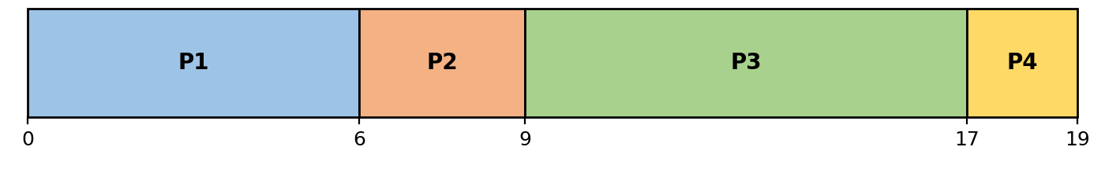
Execution order: P1 → P2 → P3 → P4
Calculations
Process | AT (ms) | BT (ms) | CT (ms) | TAT (ms) | WT (ms)
P1 | 0 | 6 | 6 | 6 | 0
P2 | 0 | 3 | 9 | 9 | 6
P3 | 0 | 8 | 17 | 17 | 9
P4 | 0 | 2 | 19 | 19 | 17
Average TAT = 51 ÷ 4 = 12.75 ms
Average WT = 32 ÷ 4 = 8 ms
Working
- P1: TAT = 6 − 0 = 6; WT = 6 − 6 = 0
- P2: TAT = 9 − 0 = 9; WT = 9 − 3 = 6
- P3: TAT = 17 − 0 = 17; WT = 17 − 8 = 9
- P4: TAT = 19 − 0 = 19; WT = 19 − 2 = 17
Additional answers
Q: Which process has the longest waiting time?
A: P4 has the longest waiting time (17 ms). It is last in the queue, so it waits for P1, P2 and P3 (6 + 3 + 8 = 17 ms) to finish.

Problem 2: FCFS — Different Arrival Times and CPU Idle Time
Given
Process | Arrival time (ms) | Burst time (ms)
P1 | 0 | 3
P2 | 5 | 4
P3 | 6 | 2
P4 | 12 | 3
Gantt chart
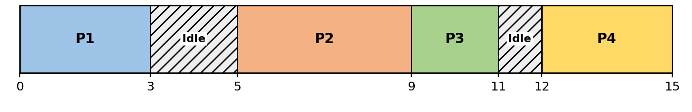
Execution order: P1 → Idle → P2 → P3 → Idle → P4
Calculations
Process | AT (ms) | BT (ms) | CT (ms) | TAT (ms) | WT (ms)
P1 | 0 | 3 | 3 | 3 | 0
P2 | 5 | 4 | 9 | 4 | 0
P3 | 6 | 2 | 11 | 5 | 3
P4 | 12 | 3 | 15 | 3 | 0
Average TAT = 15 ÷ 4 = 3.75 ms
Average WT = 3 ÷ 4 = 0.75 ms
Working
- P1: TAT = 3 − 0 = 3; WT = 3 − 3 = 0
- P2: TAT = 9 − 5 = 4; WT = 4 − 4 = 0
- P3: TAT = 11 − 6 = 5; WT = 5 − 2 = 3
- P4: TAT = 15 − 12 = 3; WT = 3 − 3 = 0
Additional answers
Q: Mark every CPU idle interval.
A: 3–5 ms (P1 finished at 3, P2 does not arrive until 5) and 11–12 ms (P3 finished at 11, P4 does not arrive until 12). Both are hatched and labelled "Idle" on the Gantt chart.
Q: Total idle time between 0 and completion of all processes?
A: 3 ms (2 ms + 1 ms) out of 15 ms total. Busy time = 3 + 4 + 2 + 3 = 12 ms.

Problem 3: SJF — All Processes Arrive Together
Non-preemptive Shortest Job First
Given
Process | Arrival time (ms) | Burst time (ms)
P1 | 0 | 7
P2 | 0 | 4
P3 | 0 | 1
P4 | 0 | 5
P5 | 0 | 2
Gantt chart
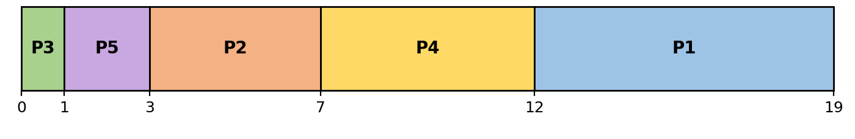
Execution order: P3 → P5 → P2 → P4 → P1
Calculations
Process | AT (ms) | BT (ms) | CT (ms) | TAT (ms) | WT (ms)
P1 | 0 | 7 | 19 | 19 | 12
P2 | 0 | 4 | 7 | 7 | 3
P3 | 0 | 1 | 1 | 1 | 0
P4 | 0 | 5 | 12 | 12 | 7
P5 | 0 | 2 | 3 | 3 | 1
Average TAT = 42 ÷ 5 = 8.4 ms
Average WT = 23 ÷ 5 = 4.6 ms
Working
- P1: TAT = 19 − 0 = 19; WT = 19 − 7 = 12
- P2: TAT = 7 − 0 = 7; WT = 7 − 4 = 3
- P3: TAT = 1 − 0 = 1; WT = 1 − 1 = 0
- P4: TAT = 12 − 0 = 12; WT = 12 − 5 = 7
- P5: TAT = 3 − 0 = 3; WT = 3 − 2 = 1
Additional answers
Q: Repeat the scheduling using FCFS. Which algorithm gives a lower average waiting time?
A: SJF gives the lower average waiting time: 4.6 ms for SJF versus 9.4 ms for FCFS. SJF runs short jobs first, so the long job (P1, 7 ms) no longer delays all the others.
FCFS for comparison (order P1 → P2 → P3 → P4 → P5)
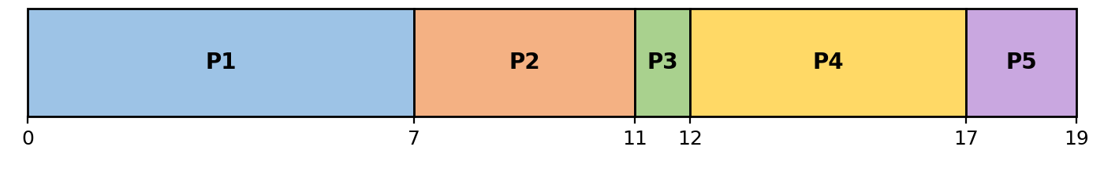
Process | AT (ms) | BT (ms) | CT (ms) | TAT (ms) | WT (ms)
P1 | 0 | 7 | 7 | 7 | 0
P2 | 0 | 4 | 11 | 11 | 7
P3 | 0 | 1 | 12 | 12 | 11
P4 | 0 | 5 | 17 | 17 | 12
P5 | 0 | 2 | 19 | 19 | 17
Average TAT = 66 ÷ 5 = 13.2 ms
Average WT = 47 ÷ 5 = 9.4 ms

Problem 4: SJF — Different Arrival Times
Non-preemptive SJF
Given
Process | Arrival time (ms) | Burst time (ms)
P1 | 0 | 8
P2 | 1 | 4
P3 | 2 | 2
P4 | 3 | 1
P5 | 10 | 3
Gantt chart
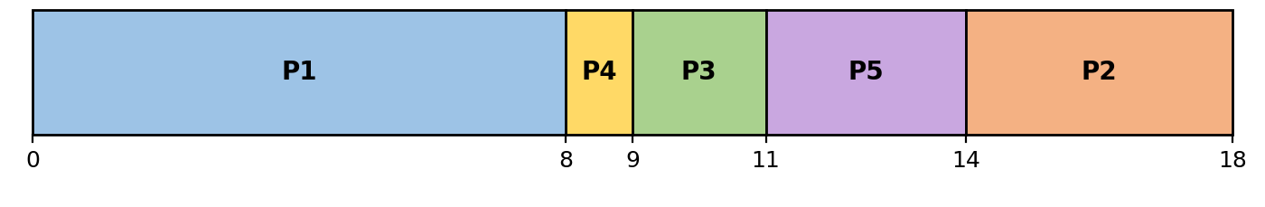
Execution order: P1 → P4 → P3 → P5 → P2
Calculations
Process | AT (ms) | BT (ms) | CT (ms) | TAT (ms) | WT (ms)
P1 | 0 | 8 | 8 | 8 | 0
P2 | 1 | 4 | 18 | 17 | 13
P3 | 2 | 2 | 11 | 9 | 7
P4 | 3 | 1 | 9 | 6 | 5
P5 | 10 | 3 | 14 | 4 | 1
Average TAT = 44 ÷ 5 = 8.8 ms
Average WT = 26 ÷ 5 = 5.2 ms
Working
- P1: TAT = 8 − 0 = 8; WT = 8 − 8 = 0
- P2: TAT = 18 − 1 = 17; WT = 17 − 4 = 13
- P3: TAT = 11 − 2 = 9; WT = 9 − 2 = 7
- P4: TAT = 9 − 3 = 6; WT = 6 − 1 = 5
- P5: TAT = 14 − 10 = 4; WT = 4 − 3 = 1
Additional answers
Q: Which process runs immediately after P1?
A: P4. At t = 8, P2 (4 ms), P3 (2 ms) and P4 (1 ms) are waiting (P5 arrives only at 10); P4 has the shortest burst.
Q: Why does P4 not interrupt P1 when it arrives?
A: SJF here is non-preemptive: once P1 starts it keeps the CPU until it finishes (t = 8), even though P4 (burst 1 ms) arrives at t = 3 and is shorter than P1’s remaining time. P4 simply waits in the ready queue until the CPU is free.

Problem 5: SRTF — Preemptive Scheduling
Shortest Remaining Time First
Given
Process | Arrival time (ms) | Burst time (ms)
P1 | 0 | 9
P2 | 1 | 5
P3 | 2 | 2
P4 | 4 | 1
Gantt chart
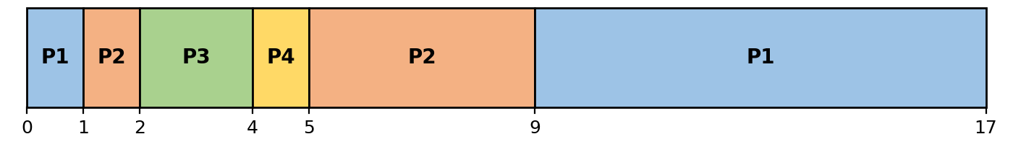
Execution order: P1 → P2 → P3 → P4 → P2 → P1
Calculations
Process | AT (ms) | BT (ms) | CT (ms) | TAT (ms) | WT (ms)
P1 | 0 | 9 | 17 | 17 | 8
P2 | 1 | 5 | 9 | 8 | 3
P3 | 2 | 2 | 4 | 2 | 0
P4 | 4 | 1 | 5 | 1 | 0
Average TAT = 28 ÷ 4 = 7 ms
Average WT = 11 ÷ 4 = 2.75 ms
Working
- P1: TAT = 17 − 0 = 17; WT = 17 − 9 = 8
- P2: TAT = 9 − 1 = 8; WT = 8 − 5 = 3
- P3: TAT = 4 − 2 = 2; WT = 2 − 2 = 0
- P4: TAT = 5 − 4 = 1; WT = 1 − 1 = 0
Additional answers
Q: Identify every preemption.
A: 1) At t = 1, P2 (burst 5) preempts P1 (remaining 8). 2) At t = 2, P3 (burst 2) preempts P2 (remaining 4). There are 2 preemptions in total. P4’s arrival at t = 4 does not preempt anything because P3 finishes at exactly t = 4.
Q: At time 4, which process should run next, and why?
A: P4. P3 has just finished. The ready processes are P1 (remaining 8), P2 (remaining 4) and P4 (remaining 1). P4 has the shortest remaining time, so it runs next.

Problem 6: Round Robin — Time Quantum of 2 ms
Given
Process | Arrival time (ms) | Burst time (ms)
P1 | 0 | 5
P2 | 0 | 4
P3 | 0 | 2
P4 | 0 | 1
Gantt chart
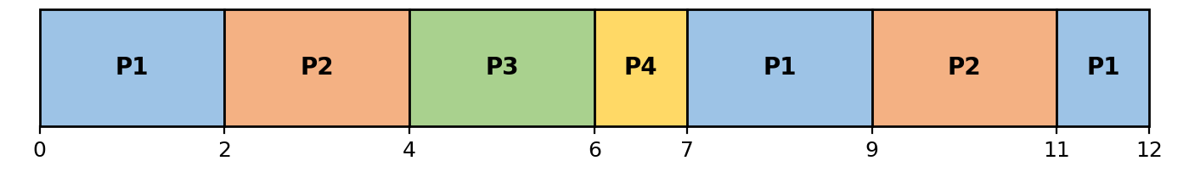
Execution order: P1 → P2 → P3 → P4 → P1 → P2 → P1
Calculations
Process | AT (ms) | BT (ms) | CT (ms) | TAT (ms) | WT (ms)
P1 | 0 | 5 | 12 | 12 | 7
P2 | 0 | 4 | 11 | 11 | 7
P3 | 0 | 2 | 6 | 6 | 4
P4 | 0 | 1 | 7 | 7 | 6
Average TAT = 36 ÷ 4 = 9 ms
Average WT = 24 ÷ 4 = 6 ms
Working
- P1: TAT = 12 − 0 = 12; WT = 12 − 5 = 7
- P2: TAT = 11 − 0 = 11; WT = 11 − 4 = 7
- P3: TAT = 6 − 0 = 6; WT = 6 − 2 = 4
- P4: TAT = 7 − 0 = 7; WT = 7 − 1 = 6
Additional answers
Q: Write the ready-queue order immediately after each time slice.
A: See the table below.
Time (ms) | Slice just run | Ready queue (front → back)
2 | P1 | P2 → P3 → P4 → P1
4 | P2 | P3 → P4 → P1 → P2
6 | P3 | P4 → P1 → P2
7 | P4 | P1 → P2
9 | P1 | P2 → P1
11 | P2 | P1
12 | P1 | empty
Q: Which process finishes first?
A: P3 finishes first, at t = 6 ms (it needs only 2 ms and gets a full quantum at 4–6). P4 follows at t = 7.

Problem 7: Round Robin — Processes Arrive During Execution
Time quantum = 3 ms
Given
Process | Arrival time (ms) | Burst time (ms)
P1 | 0 | 7
P2 | 1 | 4
P3 | 3 | 2
P4 | 5 | 5
Gantt chart
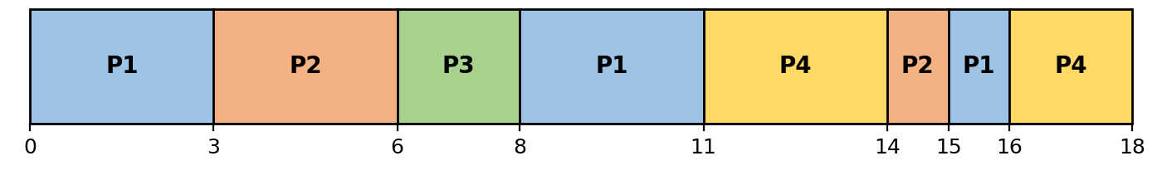
Execution order: P1 → P2 → P3 → P1 → P4 → P2 → P1 → P4
Calculations
Process | AT (ms) | BT (ms) | CT (ms) | TAT (ms) | WT (ms)
P1 | 0 | 7 | 16 | 16 | 9
P2 | 1 | 4 | 15 | 14 | 10
P3 | 3 | 2 | 8 | 5 | 3
P4 | 5 | 5 | 18 | 13 | 8
Average TAT = 48 ÷ 4 = 12 ms
Average WT = 30 ÷ 4 = 7.5 ms
Working
- P1: TAT = 16 − 0 = 16; WT = 16 − 7 = 9
- P2: TAT = 15 − 1 = 14; WT = 14 − 4 = 10
- P3: TAT = 8 − 3 = 5; WT = 5 − 2 = 3
- P4: TAT = 18 − 5 = 13; WT = 13 − 5 = 8
Additional answers
Q: Show the ready-queue order immediately after P1’s first time slice.
A: P2 → P3 → P1 (front to back).
Q: Explain where P3 is placed when it arrives at time 3.
A: P1’s first slice ends at exactly t = 3, the same moment P3 arrives. By the boundary-arrival rule, P3 enters the queue before the unfinished P1 is requeued, so P3 sits behind P2 and ahead of P1: P2 → P3 → P1.
Ready queue after every slice (empty after t = 18, when P4 finishes)
Time (ms) | Slice just run | Ready queue (front → back)
3 | P1 | P2 → P3 → P1
6 | P2 | P3 → P1 → P4 → P2
8 | P3 | P1 → P4 → P2
11 | P1 | P4 → P2 → P1
14 | P4 | P2 → P1 → P4
15 | P2 | P1 → P4
16 | P1 | P4

Problem 8: Non-Preemptive Priority Scheduling
Smaller number = higher priority
Given
Process | Arrival time (ms) | Burst time (ms) | Priority
P1 | 0 | 5 | 3
P2 | 1 | 3 | 1
P3 | 2 | 4 | 4
P4 | 3 | 2 | 2
P5 | 4 | 1 | 1
Gantt chart
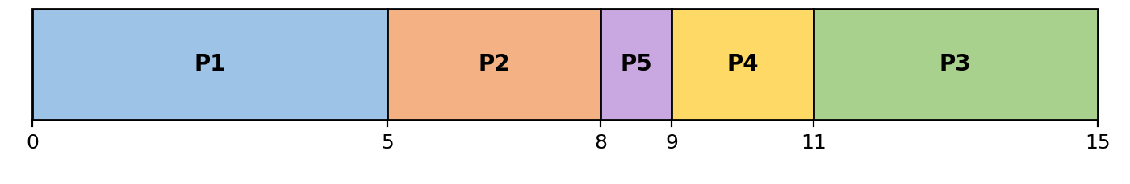
Execution order: P1 → P2 → P5 → P4 → P3
Calculations
Process | AT (ms) | BT (ms) | CT (ms) | TAT (ms) | WT (ms)
P1 | 0 | 5 | 5 | 5 | 0
P2 | 1 | 3 | 8 | 7 | 4
P3 | 2 | 4 | 15 | 13 | 9
P4 | 3 | 2 | 11 | 8 | 6
P5 | 4 | 1 | 9 | 5 | 4
Average TAT = 38 ÷ 5 = 7.6 ms
Average WT = 23 ÷ 5 = 4.6 ms
Working
- P1: TAT = 5 − 0 = 5; WT = 5 − 5 = 0
- P2: TAT = 8 − 1 = 7; WT = 7 − 3 = 4
- P3: TAT = 15 − 2 = 13; WT = 13 − 4 = 9
- P4: TAT = 11 − 3 = 8; WT = 8 − 2 = 6
- P5: TAT = 9 − 4 = 5; WT = 5 − 1 = 4
Additional answers
Q: Why does P1 continue running after P2 arrives?
A: Because the scheduling is non-preemptive. Even though P2 (priority 1) has higher priority than P1 (priority 3) and arrives at t = 1, P1 keeps the CPU until its burst completes at t = 5.
Q: When the CPU becomes free, how is the tie between P2 and P5 resolved?
A: At t = 5 the ready processes are P2 (priority 1), P3 (4), P4 (2) and P5 (priority 1). P2 and P5 tie for the highest priority. The tie-breaker is earlier arrival: P2 arrived at t = 1 and P5 at t = 4, so P2 runs first (5–8), then P5 (8–9).

Problem 9: Preemptive Priority Scheduling
Smaller number = higher priority
Given
Process | Arrival time (ms) | Burst time (ms) | Priority
P1 | 0 | 8 | 4
P2 | 1 | 4 | 2
P3 | 2 | 2 | 1
P4 | 3 | 3 | 3
P5 | 5 | 1 | 1
Gantt chart
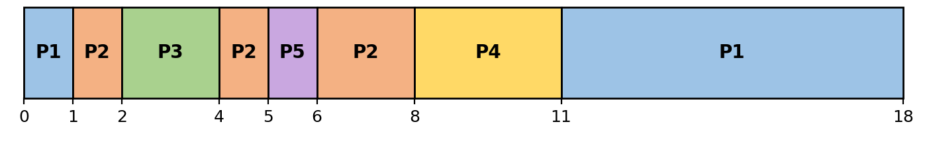
Execution order: P1 → P2 → P3 → P2 → P5 → P2 → P4 → P1
Calculations
Process | AT (ms) | BT (ms) | CT (ms) | TAT (ms) | WT (ms)
P1 | 0 | 8 | 18 | 18 | 10
P2 | 1 | 4 | 8 | 7 | 3
P3 | 2 | 2 | 4 | 2 | 0
P4 | 3 | 3 | 11 | 8 | 5
P5 | 5 | 1 | 6 | 1 | 0
Average TAT = 36 ÷ 5 = 7.2 ms
Average WT = 18 ÷ 5 = 3.6 ms
Working
- P1: TAT = 18 − 0 = 18; WT = 18 − 8 = 10
- P2: TAT = 8 − 1 = 7; WT = 7 − 4 = 3
- P3: TAT = 4 − 2 = 2; WT = 2 − 2 = 0
- P4: TAT = 11 − 3 = 8; WT = 8 − 3 = 5
- P5: TAT = 6 − 5 = 1; WT = 1 − 1 = 0
Additional answers
Q: Identify every preemption.
A: 1) t = 1: P2 (priority 2) preempts P1 (priority 4). 2) t = 2: P3 (priority 1) preempts P2. 3) t = 5: P5 (priority 1) preempts P2 (priority 2, resumed at t = 4). P4 (priority 3) arrives at t = 3 while P3 (priority 1) is running, so it does not preempt anything; it runs only after P2 finishes (8–11).
Q: Which process has the longest waiting time?
A: P1 with WT = 10 ms. It has the lowest priority (4), so it only runs for 1 ms at the start and then waits until all others finish at t = 11.

Problem 10: Compare Four Scheduling Algorithms
FCFS, non-preemptive SJF, SRTF and Round Robin (q = 2 ms)
Given
Process | Arrival time (ms) | Burst time (ms)
P1 | 0 | 6
P2 | 1 | 3
P3 | 2 | 1
P4 | 3 | 4
FCFS
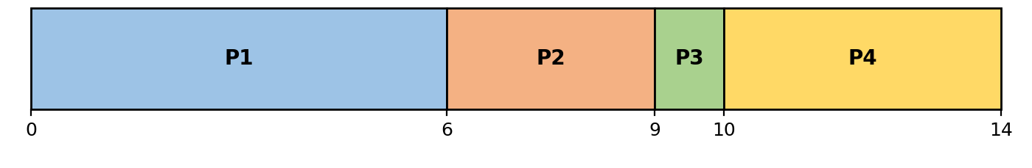
Execution order: P1 → P2 → P3 → P4
Process | AT (ms) | BT (ms) | CT (ms) | TAT (ms) | WT (ms)
P1 | 0 | 6 | 6 | 6 | 0
P2 | 1 | 3 | 9 | 8 | 5
P3 | 2 | 1 | 10 | 8 | 7
P4 | 3 | 4 | 14 | 11 | 7
Average TAT = 33 ÷ 4 = 8.25 ms
Average WT = 19 ÷ 4 = 4.75 ms
SJF (non-preemptive)
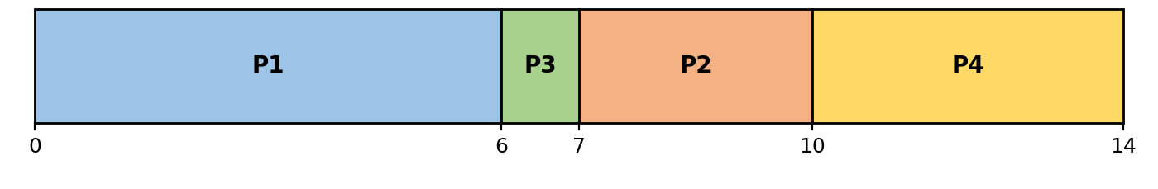
Execution order: P1 → P3 → P2 → P4
Process | AT (ms) | BT (ms) | CT (ms) | TAT (ms) | WT (ms)
P1 | 0 | 6 | 6 | 6 | 0
P2 | 1 | 3 | 10 | 9 | 6
P3 | 2 | 1 | 7 | 5 | 4
P4 | 3 | 4 | 14 | 11 | 7
Average TAT = 31 ÷ 4 = 7.75 ms
Average WT = 17 ÷ 4 = 4.25 ms
SRTF (preemptive)
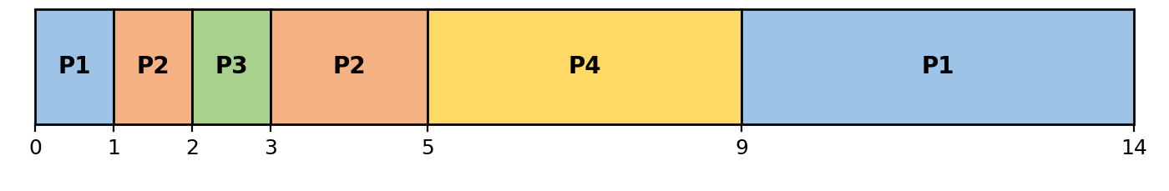
Execution order: P1 → P2 → P3 → P2 → P4 → P1
Process | AT (ms) | BT (ms) | CT (ms) | TAT (ms) | WT (ms)
P1 | 0 | 6 | 14 | 14 | 8
P2 | 1 | 3 | 5 | 4 | 1
P3 | 2 | 1 | 3 | 1 | 0
P4 | 3 | 4 | 9 | 6 | 2
Average TAT = 25 ÷ 4 = 6.25 ms
Average WT = 11 ÷ 4 = 2.75 ms
Round Robin (q = 2 ms)
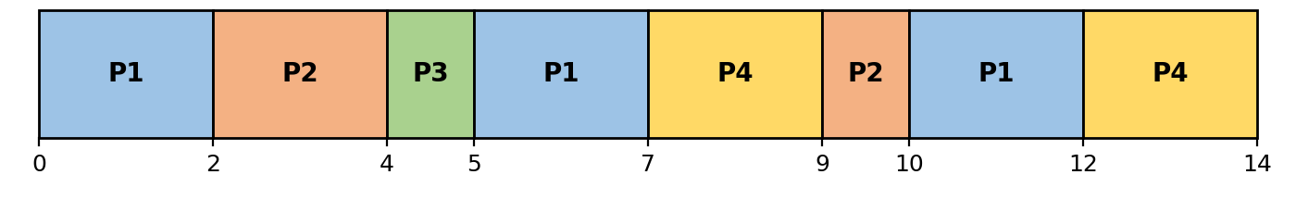
Execution order: P1 → P2 → P3 → P1 → P4 → P2 → P1 → P4
Process | AT (ms) | BT (ms) | CT (ms) | TAT (ms) | WT (ms)
P1 | 0 | 6 | 12 | 12 | 6
P2 | 1 | 3 | 10 | 9 | 6
P3 | 2 | 1 | 5 | 3 | 2
P4 | 3 | 4 | 14 | 11 | 7
Average TAT = 35 ÷ 4 = 8.75 ms
Average WT = 21 ÷ 4 = 5.25 ms

Comparison
Algorithm | Average TAT (ms) | Average WT (ms)
FCFS | 8.25 | 4.75
SJF | 7.75 | 4.25
SRTF | 6.25 | 2.75
Round Robin (q = 2 ms) | 8.75 | 5.25
Additional answers
Q: Which algorithm gives the lowest average waiting time?
A: SRTF with 2.75 ms (FCFS 4.75, SJF 4.25, Round Robin 5.25).
Q: Does that algorithm also give the lowest average turnaround time?
A: Yes. SRTF also has the lowest average TAT, 6.25 ms (FCFS 8.25, SJF 7.75, Round Robin 8.75). Since TAT = WT + BT and the burst times are the same in every algorithm, the algorithm with the lowest average WT will always have the lowest average TAT.
Q: Do any algorithms produce the same execution order for this process set?
A: No. All four orders differ: FCFS = P1, P2, P3, P4; SJF = P1, P3, P2, P4; SRTF = P1, P2, P3, P2, P4, P1; Round Robin = P1, P2, P3, P1, P4, P2, P1, P4. FCFS and SJF come closest, differing only in whether P2 or P3 runs after P1.

